* Admin Login Page

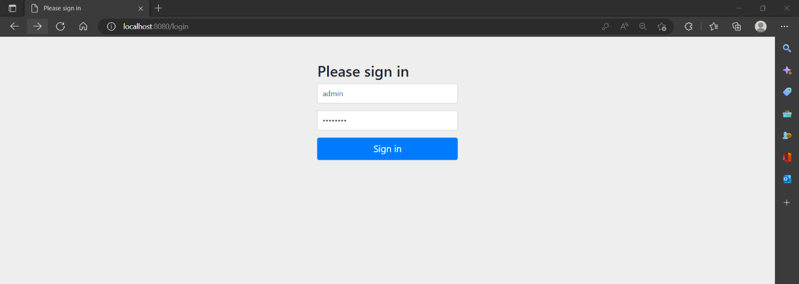

* Admin – Student List

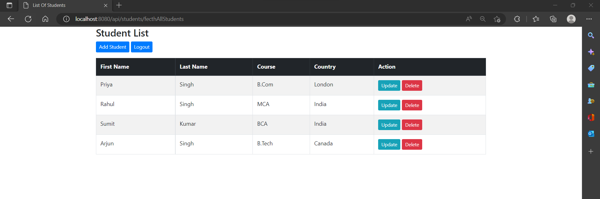

* Admin – Adding Student Detail

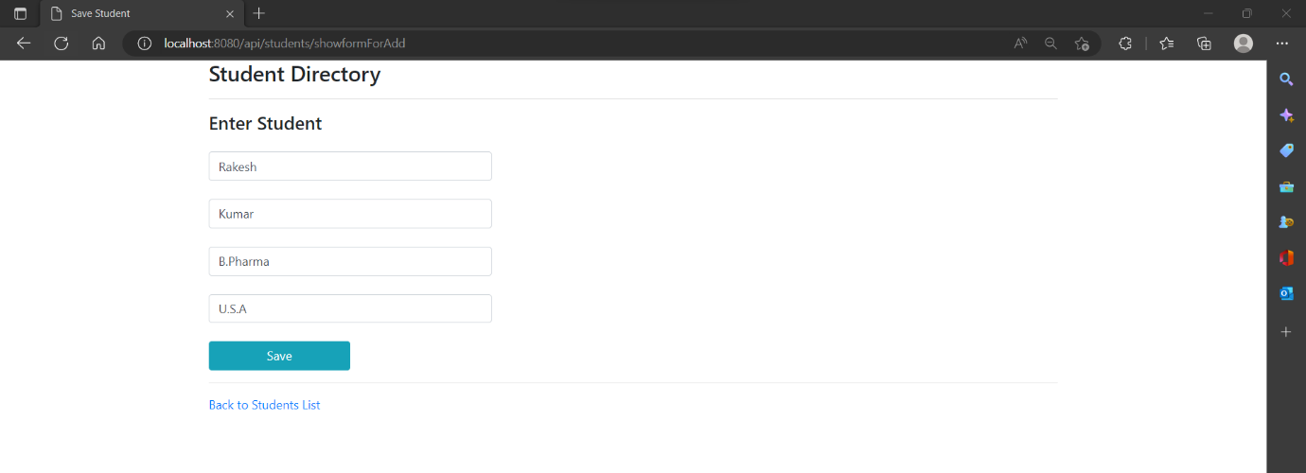

* Admin – After adding Student Details

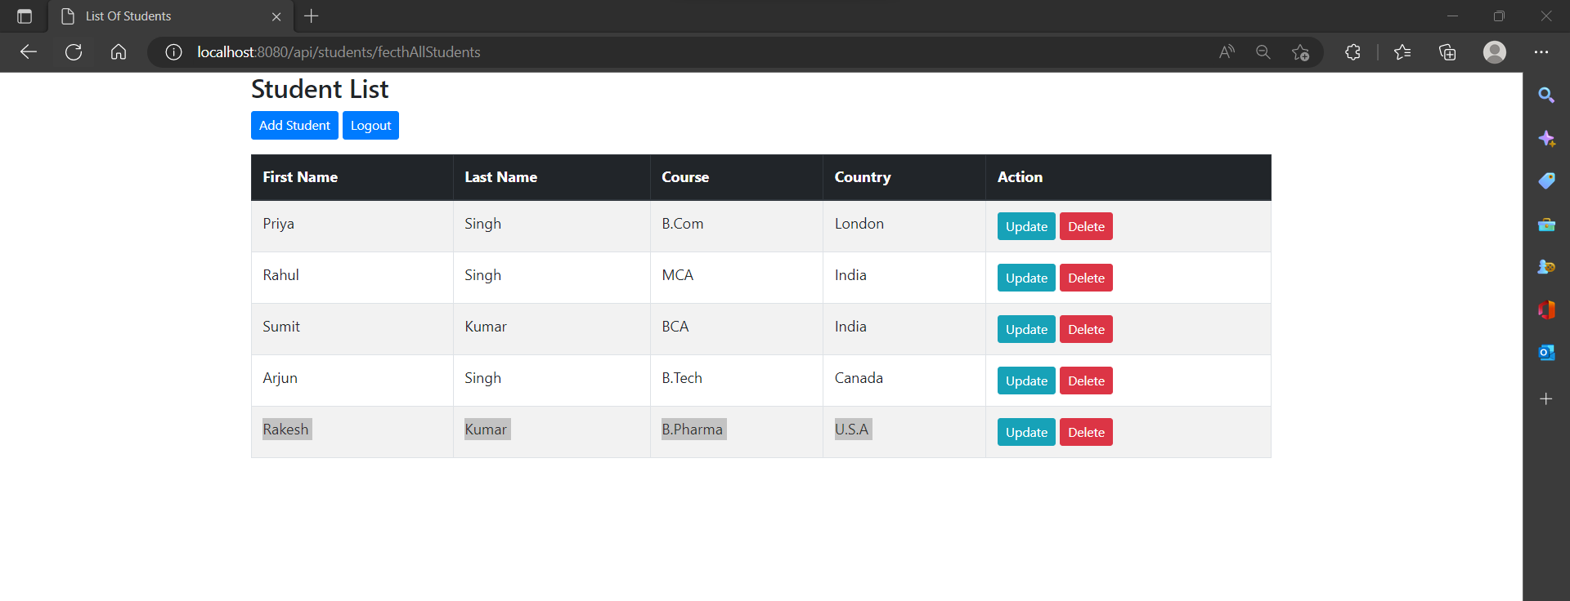

* Admin – Updating Student Details

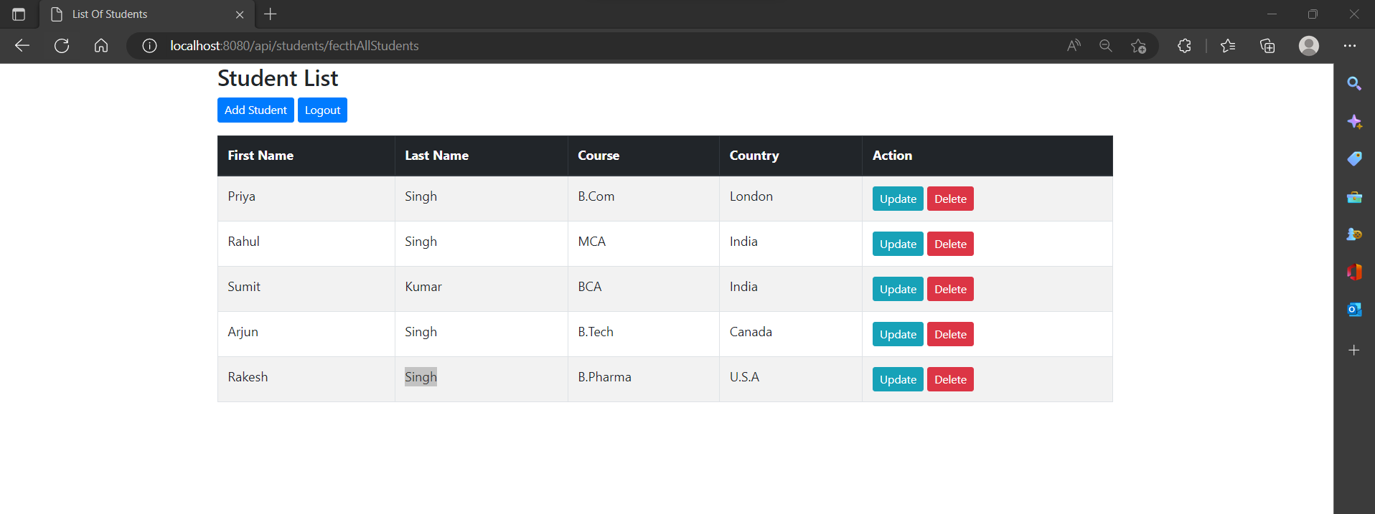

* Admin – Deleting Student Detail

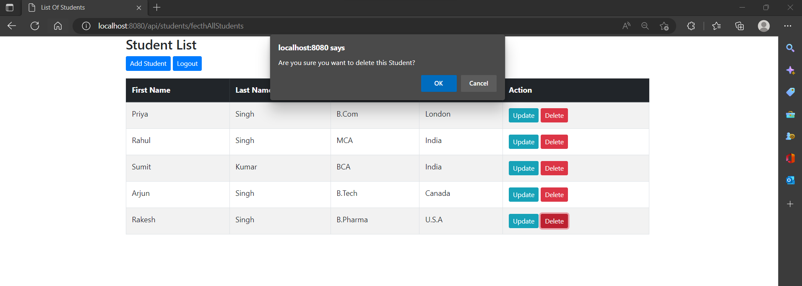

* Admin – After Deleting Data

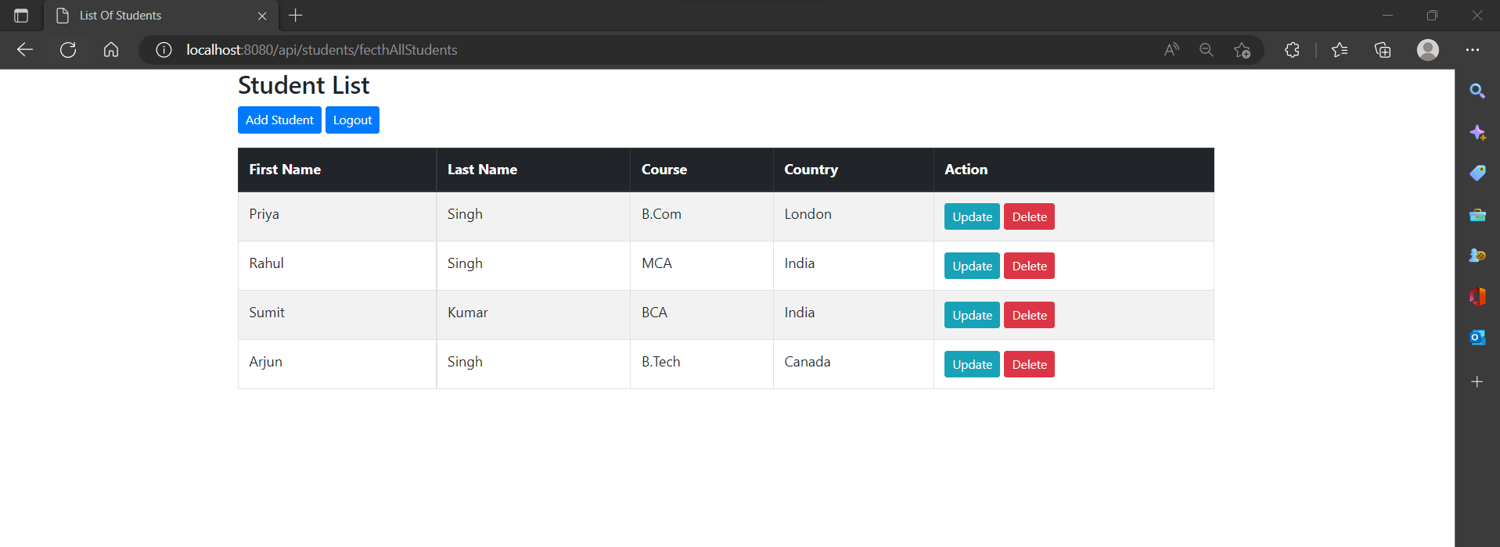

* Sumit (user) Login Page

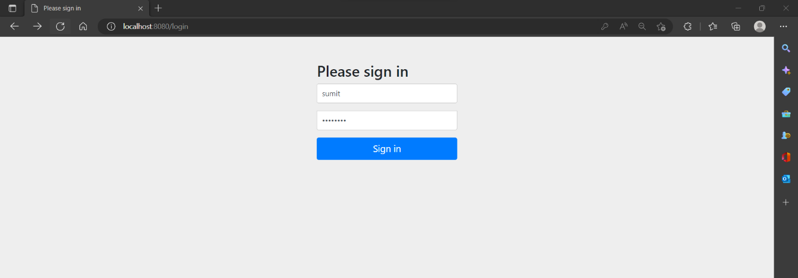

* 403 Error

